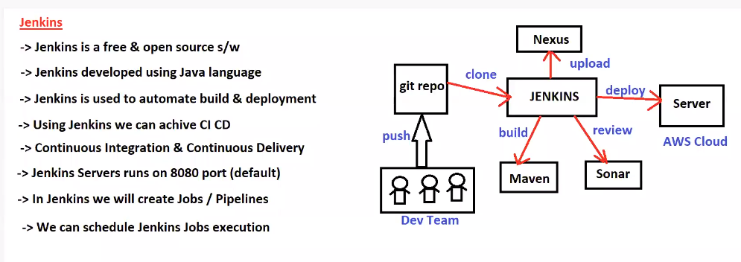

**Jenkins jobs is nothing but set of steps to perform build & deployment**

**We can create 2 types of job in Jenkins**

1. **Free style Project (GUI)**
2. **Pipeline (Script)**

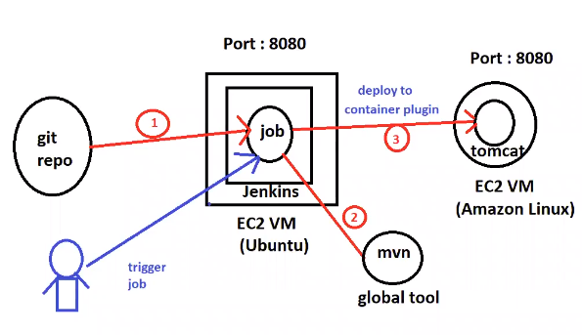

**Plugin is used to perform the task.**

**Master and Slave Configuration:**

* **For every project will create a one Jenkins job ( like Micro services)**
* **Multiple developers are running Jenkins job parallelly**
* **If we run multiple jobs at a time, then load will increase on Jenkins servers**
* **To reduce load on Jenkins server will user Master and Slave Configuration in Jenkins.**
* **Jobs will be created on Master machines and jobs execution happen on slave machines**
* **Jenkins s/w will be installed only on master machines and in slave machines only java S/W will be installed**
* **For example:**
* **If project will have 10 Micro services. For every micro service will create a job in Jenkins**
* **In these cases, multiple developers are running the job parallelly**
* **If multiple jobs running at a time, then Jenkins server will be down or waiting period will be available.(first job complete, then only run second job like this will happened)**
* **It is not all recommended multiple jobs are running at single machines.**

**Note: we need to create Slave machines and attached with master machine .**

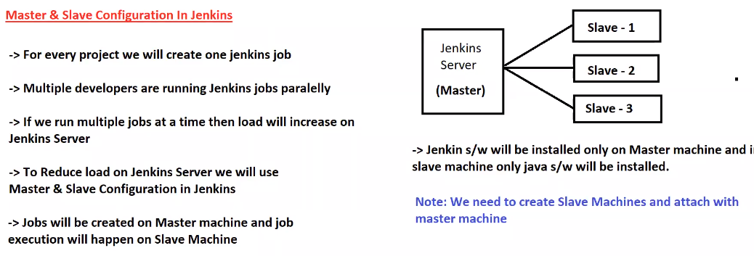

**Jenkins Pipeline:**

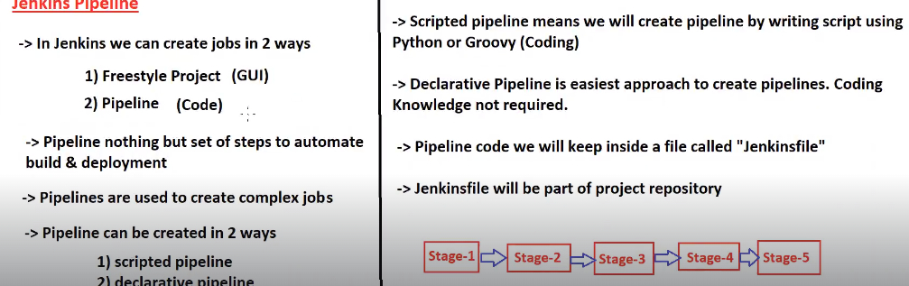

**In Jenkins we can create jobs in 2 ways**

1. **Free style (GUI)**
2. **Pipeline (Code Based)**

**Pipeline nothing but set of steps to automate build and deployment**

**Pipeline are used to create Complex jobs**

**Pipeline can be created in two ways**

1. **Scripted Pipeline**
2. **Declarative Pipeline**

**Scripted Pipeline:**

**Scripted pipeline means we will create pipeline by writing script using python or Groovy (coding)**

**Declarative Pipeline:**

**Declarative Pipeline is easiest approach to create pipeline. Coding knowledge not required.**

**Pipeline code will keep inside a file called Jenkins file**

**Jenkins file will be part of project repository .**

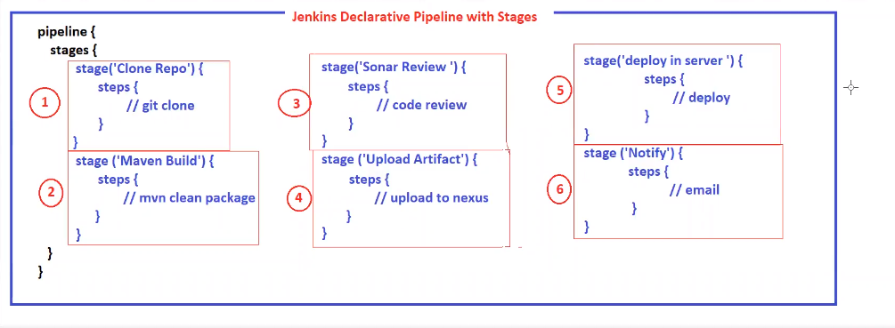

**Pipeline is nothing but collection Stages.**

**https://github.com/arunkeerthi/newmavenproject**

**Environment Setup:**

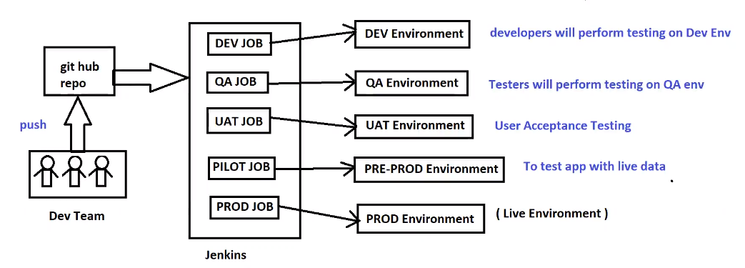

**Only Prod environment url for given public access,**

**Rest of them environment using within the company**

**How to Create Jenkins Jobs with Build Parameters**

**----------------------------------------------------------------------------------------------------------------**

**Build parameters are used to supply input to run the job. Using Build Parameters, we can avoid hard coding**

**we can give the dynamic pass value for input of the job.**

**Ex: We can pass branch name as build parameters**

**-> Create New Item**

**-> Enter Item Name & Select Free Style Project**

**-> Select "This Project is parameterized" in General Section**

**-> Select Choice Parameter-> string parameter**

**-> Name : BranchName**

**-> default value: master**

**-> Description -> Optional , Trim the string**

**-> SCM-> update (Git hub url)**

**-> Branches to Build : */${BranchName}**

**-> go and run job-> it will ask which branch ; do we want to run the job -> give the branch name and run the job**

**---------------Go and check the consul output result, it will show branch name which we mentioned while run the job ,**

**using string Parameters, we have to type the branch**

**Choice Parameters we can choose the branch names which we configure as our customize.**